Fisheye Visual Odometry Assignment Overview
Implement a fisheye visual odometry pipeline that undistorts drone footage, tracks features with Lucas–Kanade flow, and recovers a relative trajectory via homography decomposition.

Learning Goals
- Parse camera intrinsics and build distortion-free rectification maps.
- Design a grid-aware detector and run pyramidal LK tracking.
- Robustly estimate homographies, select plausible pose candidates, and integrate motion.
- Visualize tracked correspondences and trajectories, and compare them against reference coordinates.

Provided Resources
Resource | Description | Placeholder
Notebook | Structured sections and TODO stubs. | homework.ipynb
Video & metadata | Fisheye video close to nadir and metadata provided by the company FoxFour
Utility module | Supplies plotting, video overlay, and trajectory helper classes. | pose_helpers.py
Dataset | Recording, fisheye calibration JSON, and ground-truth CSV. | flight/

Required Tasks
- Undistortion: Complete load_camera_intrinsics, create_fisheye_rectification_maps, and undistort_with_maps.
Expected result:
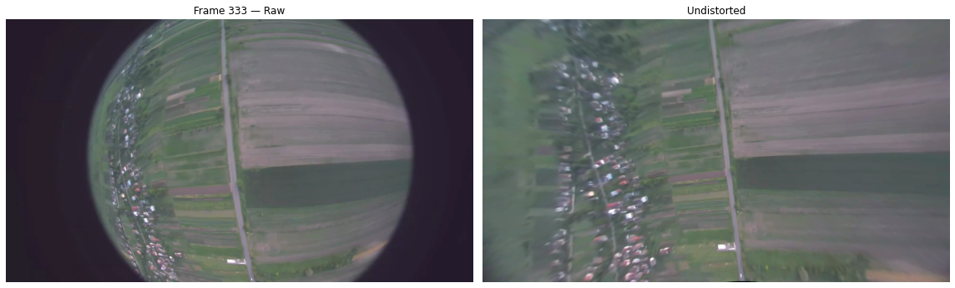
- Feature Detection & Tracking:
  - Implement good_features to enforce even spatial sampling over a grid.
  - Fill compute_good_feature_tracks and define sensible LK parameters.
Expected result:
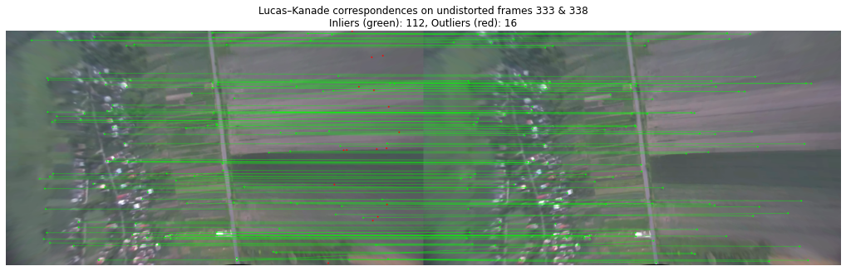
- Trajectory Recovery: Finish recover_homography_trajectory, including feature reacquisition logic, RANSAC-based homography computation, decomposition, pose chaining, and video writing.
  - Pose Selection: Ensure that choose_pose_candidate selects the homography solution with a normal closest to [0, 0, 1].
Expected result: You should get a trajectory that is more or less similar to GT. Don’t expect it to be perfect! Reference results that you might expect:
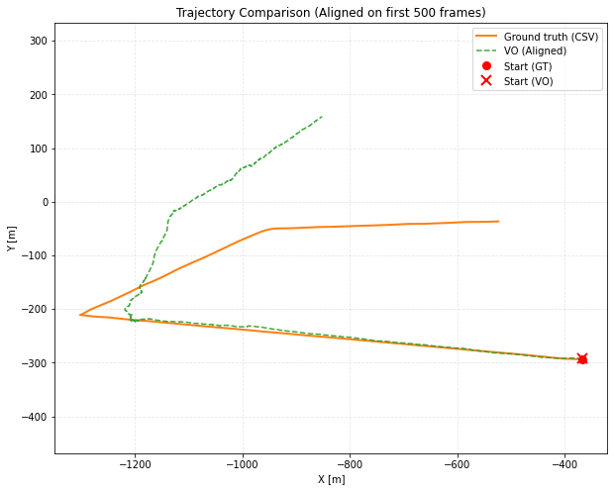

Deliverables
- Executable notebook with all code cells run and plots rendered.
- Short summary (markdown cell) describing implementation choices, parameter tuning, and observed trajectory quality.
- Generated an overlay video and write summary on the performance of your algorithm
- You can get 15 points in total:
  - 7 points → quality of deliverables + correctness/clarity of code
  - 8 points → defence (your ability to justify choices, answer questions, and demonstrate understanding)

Known Assumptions and Limitations
- For the purpose of this exercise, we assume that our camera pose is always close to nadir, although it’s not always true
- The provided method does not provide the absolute scale measurements
- The provided homography-based method will have a certain degree of drift. That’s alright! You will learn how to reduce it in the next lecture.

